Web Scrapping Scenarios :

Scenario-1:
- Open google.com.
- Enter “Test Automation” in the search box.
- Capture all the search options and validate with your expected options list.
- Capture the options count and validate with your expected options count.
- Display all the options
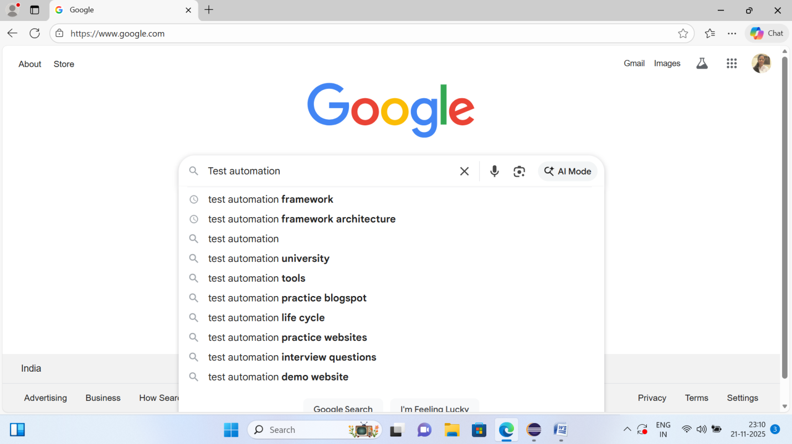
Use :
- Method library
- TestNG Script

Scenario-2:
- Open the amazon.in
- Click on All.
- Get all the options or elements available in dropdown and validate with the expected list.
- Get all the options count and validate with expected options count.
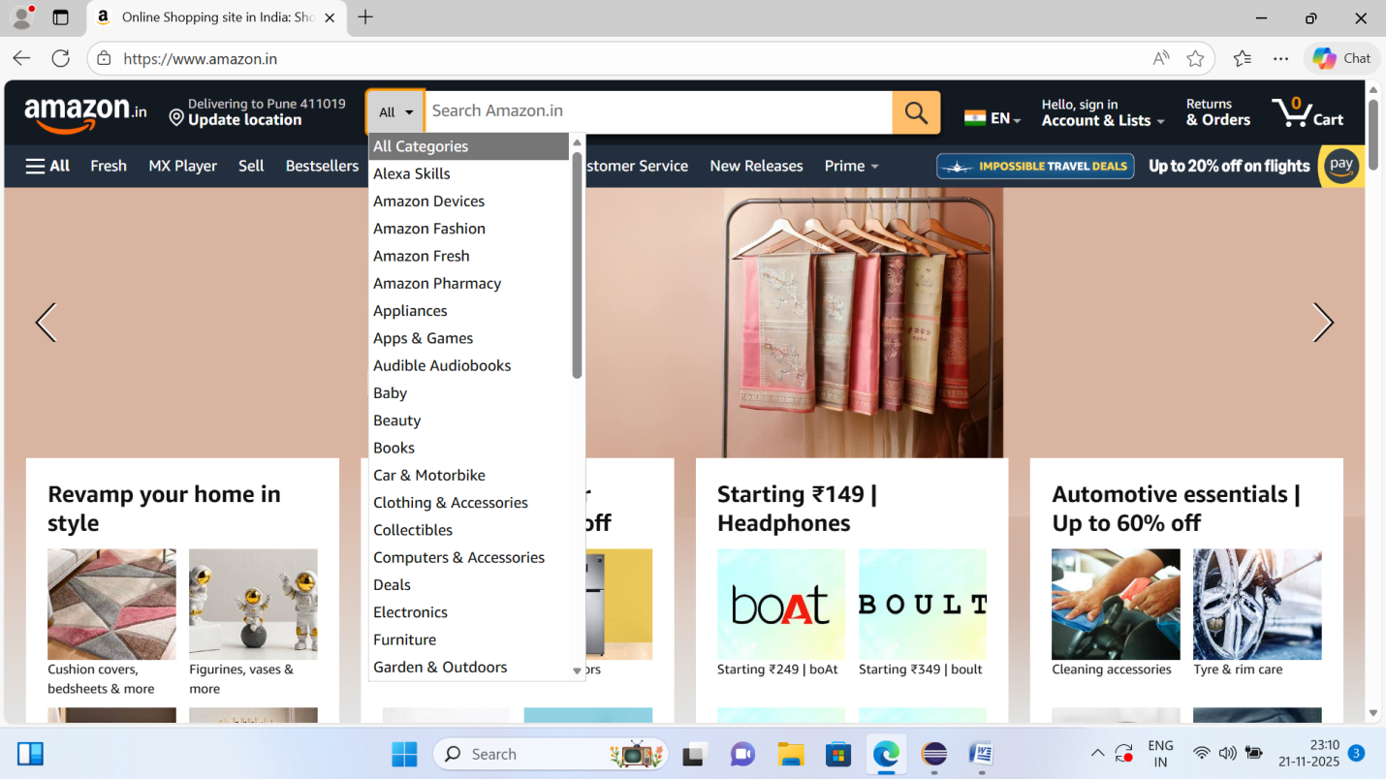
Use:
- Method Library
- TestNG Script
Scenario – 3:

- Open amazon.in
- Count the total number of links and validate the same with the expected link counts.
- Fetch link names in a list and validate the same with expected ListName

Scenario – 4:
- Open amazon.in
- Count number of images present in the page and validate the same with expected number of images.

Scenario-5:
- Launch makemytrip
- Click on flights
- Get all options from From
- Get all options from To
- Assert From and To data

